**CITY OF SANDERSVILLE, GEORGIA**

**SPEED HUMP PROGRAM**

**MANUAL**

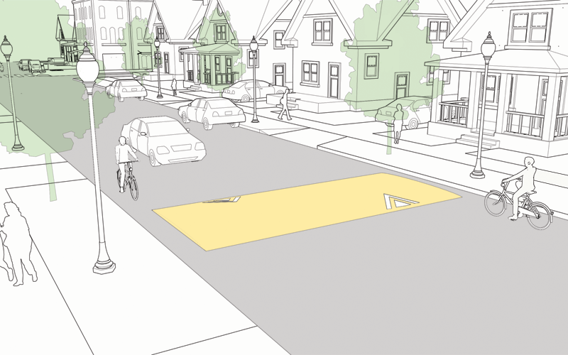



**CITY OF SANDERSVILLE**

**OFFICE OF PUBLIC WORKS**

**JANUARY 2021**

**TABLE OF CONTENTS**

**POLICIES AND PROCEDURES ……………………………………………….. 1**

**SPEED HUMP ELIGIBILITY CRITERIA**

**INSTALLATION**

**CACULATING 85TH PERCENTILE SPEED .………………………… 2**

**MOTOR VEHCILE SPEED SHEET .…………………………………… 3**

**SPEED HUMP REMOVAL ……………………………………………… 4**

**DESIGN AND SPACING**

**SPEED HUMP TYPICAL SECTION …………………………………..………. 5**

**PETITION FOR SPEED HUMPS ………………………………………………. 6**

**SIGNATURE SHEET FOR SPEED HUMPS ………….……………………… 7**

**PROCESS FLOW CHART …………………………………………………………. 8**

**CITY OF SANDERSVILLE**

**SPEED HUMP POLICIES**

In response to numerous complaints about speeding problems in neighborhoods, the Sandersville Public Works Department has developed a policy on the use of speed humps. This policy is based on the requirements and recommendations of the Institute of Transportation Engineers. The following criteria has been established to determine eligibility for the installation of speed humps in neighborhoods where requested by citizens residing therein.

**SPEED HUMP ELIGIBILITY CRITERIA**

In order to install speed hump(s) on a particular street, the street must meet the following criteria:

1. The street must be classified as a local street as defined in the City Ordinance.
2. The street grade must not exceed 8%.
3. The posted speed must be 35 MPH or less.
4. The street must NOT be a primary bus route or truck route as defined in the City Ordinance.
5. The street must NOT be a primary emergency vehicle route (such as a main approach to a hospital or fire station).
6. Letters from both the Fire Chief and Police Chief stating any conflict with response time and an alternate route plan, if available, must be submitted with the request prior to installation of any speed hump.
7. The 85th percentile of measured vehicle speeds must exceed the posted speed limit by 15 MPH.

**INSTALLATION:**

The City of Sandersville will only consider installation of speed humps on streets classified as local two-way residential streets with traffic volumes less than 3,000 vehicles per day and a posted speed limit of 35 mph or less and with maximum vertical grades or eight percent (8%). With the above requirements met, the procedures to be followed are:

1. Any property owner in any area of the city or the homeowners of a neighborhood may submit a Letter of Request for a Speed Hump that their neighborhood be reviewed for the installation of a speed hump on a particular street. This letter may be presented to the Mayor and Council during a regular session of the City Council. Letters referred to in # 6 above must also be attached to the request.
2. Upon approval of the Mayor and Council, a Traffic Study will be performed by the Public Works Department. This study must find a speeding problem of at least 15 mph over the posted speed limit as the 85th percentile speed*. Results of the traffic study will be presented to the Mayor and Council at the earliest regular session of the City Council.
3. If the traffic study justifies the need for a speed hump the petitioner shall then secure a formal petition of the affected property owners of the neighborhood.
4. The petitions will be verified by the Public Works Department. Petitions must represent 75% of the served area in favor of the speed hump(s).
5. A public hearing will be held to allow public input either in favor or against the installation of the speed humps.
6. If the City Council approves the requested speed hump or humps, the installation will be completed within six months.
7. Cost for the installation of the speed hump will be shared by all property owners who by definition of public works and the petition are served by such traffic control device(s).

### \***CALCULATING 85th PERCENITLE SPEED**

The following procedure to calculate the 85th percentile speed will be used:

1. Add the tally marks as shown in the “Cumulative Total” column in Figure A-1. Note that the marks are added from the bottom up.
2. For each “Cumulative Total” column, calculate 85 percent of the total number of vehicles checked.

EXAMPLE: Figure A-1 shows that 125 cars were counted in the northbound direction. So, 85 percent would be 106 (125 x 0.85 = 106). Thus, the 106th car (counting up from the bottom) represents the 85th percentile speed.

1. Determine the speed at which the car representing the 85th percentile was traveling. Again, from the northbound example in Figure A-1, the 106th car was traveling at 48 miles per hour. Thus, 48 miles per hour is the 85th percentile speed.

In no case shall the 85th percentile speed be interpolated between two speeds in the M.P.H. column.

After the locations of the speed check stations have been decided upon and the speed checks have been made, the 85th percentile speeds should be calculated immediately in the field. By doing so, it is possible to get an idea of what the speed curve will look like and to determine if more speed check stations are needed.

Sandersville Department of Public Works **MOTOR VEHICLE SPEED SHEET Figure A-1 Vehicle Tally Sheet**

**Date:** ___1/8/21__________ **Road:** ____Floyd Street_________ **Location:** ___725 Floyd Street_______

**Time:** __1/7/21 9:00 AM____ **to:** _1/8/21 9:00 AM___________ **Weather:** Clear and sunny__________

|  |  |  |  |  |  |  |  |  |
| --- | --- | --- | --- | --- | --- | --- | --- | --- |
|  | Automobiles | Cumulative  Total | Automobiles | Cumulative  Total | Trucks and Busses | | Cumulative  Total |  |
| MPH | Direction  West Bound | Direction  East Bound | Direction  East | Direction  West | MPH |
| 70 + |  |  |  |  |  |  |  | 70 + |
| 69 |  |  |  |  |  |  |  | 69 |
| 68 |  |  |  |  |  |  |  | 68 |
| 67 |  |  |  |  |  |  |  | 67 |
| 66 |  |  |  |  |  |  |  | 66 |
| 65 |  |  |  |  |  |  |  | 65 |
| 64 |  |  |  |  |  |  |  | 64 |
| 63 |  |  |  |  |  |  |  | 63 |
| 62 |  |  |  |  |  |  |  | 62 |
| 61 |  |  |  |  |  |  |  | 61 |
| 60 |  |  |  |  |  |  |  | 60 |
| 59 |  |  |  |  |  |  |  | 59 |
| 58 |  |  |  |  |  |  |  | 58 |
| 57 |  |  |  |  |  |  |  | 57 |
| 56 |  |  |  |  |  |  |  | 56 |
| 55 |  |  |  |  |  |  |  | 55 |
| 54 |  |  |  |  |  |  |  | 54 |
| 53 | 1 | 125 |  |  |  |  |  | 53 |
| 52 |  |  | 1 | 125 |  |  |  | 52 |
| 51 | 1 | 124 | 2 | 124 |  |  |  | 51 |
| 50 | 2 | 123 | 2 | 122 |  |  |  | 50 |
| 49 | 2 | 121 | 5 | 120 |  |  |  | 49 |
| 48 | 17 | 119 | 16 | 115 |  |  |  | 48 |
| 47 | 25 | 102 | 23 | 99 | 1 |  | 53 | 47 |
| 46 | 25 | 77 | 26 | 76 | 2 | 1 | 52 | 46 |
| 45 | 26 | 52 | 25 | 50 | 2 | 3 | 49 | 45 |
| 44 | 12 | 26 | 13 | 25 | 3 | 3 | 44 | 44 |
| 43 | 6 | 14 | 5 | 12 | 3 | 3 | 38 | 43 |
| 42 | 3 | 8 | 3 | 7 | 3 | 4 | 32 | 42 |
| 41 | 3 | 5 | 2 | 4 | 2 | 5 | 25 | 41 |
| 40 | 1 | 2 | 2 | 2 | 5 | 4 | 18 | 40 |
| 39 | 1 | 1 |  |  | 3 | 2 | 9 | 39 |
| 38 |  |  |  |  | 1 | 1 | 4 | 38 |
| 37 |  |  |  |  |  | 1 | 2 | 37 |
| 36 |  |  |  |  | 1 |  | 1 | 36 |
| 35 |  |  |  |  |  |  |  | 35 |
| 34 |  |  |  |  |  |  |  | 34 |
| 33 |  |  |  |  |  |  |  | 33 |
| 32 |  |  |  |  |  |  |  | 32 |
| 31 |  |  |  |  |  |  |  | 31 |
| <30 |  |  |  |  |  |  |  | <30 |

**Total Automobiles:** 125 **85th Percentile Automobile:** 106 **Total Automobiles:** 125 **85th Percentile Automobile:** 106

**85th Percentile Speed MPH:** 48 **85th Percentile Speed MPH:** 45

**SPEED HUMP REMOVAL**

The City will remove a speed hump under the following conditions:

1. 75% of property owners request by formal petition the removal and the City Council approves the request.
2. The speed hump has been in place at least 2 years; and,
3. The homeowners are made aware that vehicle speeds may increase once the speed hump is removed.

NOTE: For subdivisions not completely built out, a minimum of 75% of the total units must be occupied before a petition for the installation of speed humps will be considered, and a minimum of 75% of the total units must be occupied before a petition for the removal of a speed hump will be considered.

**DESIGN AND SPACING**

The geometric design of the speed hump has been proven to be a critical factor in their effectiveness. Based on extensive research, speed humps will be constructed to adhere to the following specifications:

1. 4” maximum vertical rise

22’ in horizontal length

6’ incline/10’ flat top/6’ decline

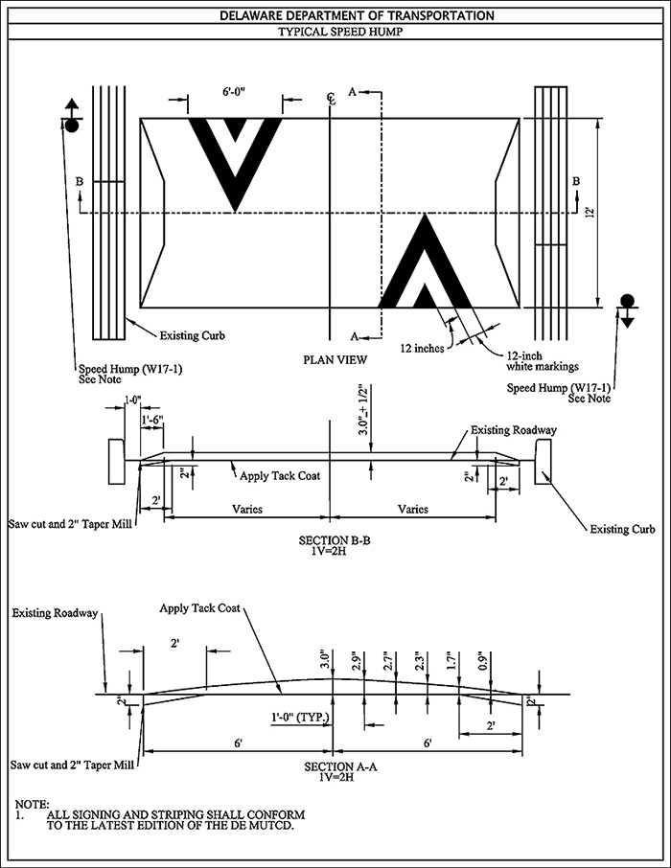Figure A-2 Typical Speed Hump Design

1. Speed humps shall be installed across the entire roadway width to the lip of the gutter, with the last one-foot tapered flush with the pavement. The tapered design is intended to minimize gutter blockage and preserve drainage flows.
2. Speed humps must meet City Specifications for Asphalt Speed Hump Construction and must be approved by the Public Works Director.
3. The maximum spacing between speed humps and/or controlled intersections will be four hundred feet (400’) or less.
4. Speed humps shall be placed in locations where drivers have adequate sight distance to see vertical deflection on the roadway surface; and avoids conflicts with other transportation and utility infrastructure.
5. In general, speed humps shall be installed at least 200 feet apart but not greater than 750 feet apart unless special circumstances dictate otherwise.
6. The positioning of the speed humps shall take into consideration the following which shall be field verified prior to installation:
   1. Speed humps will NOT be installed in the path of a pedestrian crossing or curb ramp.
   2. Speed humps will NOT be constructed at driveway locations.
   3. Speed humps should be located to avoid conflict with underground utility access to boxes, vaults and sewers.
   4. Speed humps will NOT be installed over manholes, water valves or adjacent to fire hydrants.
   5. Speed humps located near drainage inlets will be installed on the down slope side of the inlet. This arrangement promotes positive drainage flow to the inlet.
   6. Speed humps will be located near a streetlight to ensure nighttime illumination.
   7. The speed humps will NOT be located on horizontal or vertical curves where visibility of the speed hump is limited, or on approach to these curves. The speed hump must be visible from a distance of at least 250 feet using the AASHTO (American Association of State Highway and Transportation Officials) measurement procedures. Speed humps will not be used on curves unless the radius is greater than 300 feet.
   8. Speed humps will NOT be installed less than 150 feet from a stop sign or yield sign, and not less than 250 feet from a traffic signal.
   9. Under no circumstance will a speed BUMP be utilized as a replacement for a speed hump. Speed bumps are not approved traffic control devices for use on public streets.



**CITY OF SANDERSVILLE**

**OFFICE OF PUBLIC WORKS**

141 W. Haynes Street

Sandersville, GA 31082

PHONE (478) 552-3459 * FAX (478) 552-2410

**LETTER OF REQUEST FOR A SPEED HUMP**

WE THE UNDERSIGNED, ALL BEING PROPERTY OWNERS OF THE NEIGHBORHOOD KNOWN AS ________________________________________________ DO HEREBY PETITION THROUGH OUR NEIGHBORHOOD FOR THE INSTALLATION OF A SPEED HUMP ON __________________________________ STREET.

THIS LETTER REPRESENTS _______% OR MORE OF THE PROPERTY OWNERS OF THIS AREA TO BE AFFECTED (AS DETERMINED BY PUBLIC WORKS) WHO HEREBY JOIN IN THIS REQUEST.

MY SIGNATURE ON THIS LETTER INDICATES THAT I HAVE READ AND UNDERSTAND ALL THE INFORMATION CONCERNING THE SPEED HUMP PROGRAM.

I STATE THAT I AM ACTING AS A REPRESENTATIVE OF MY NEIGHBORHOOD AND THAT I AM ACTING ON THE BEHALF OF MYSELF AND MY NEIGHBORS IN THIS REQUEST FOR A SPEED HUMP. I STATE THAT I AM A PROPERTY OWNER OF THE NEIGHBORHOOD OF WHICH I MAKE THIS REQUEST AND I AM MAKING THIS REQUEST FOR THE BENEFIT AND SAFETY OF MY NEIGHBORS. I AGREE THAT I WILL FOLLOW THE CITY OF SANDERSVILLE GUIDELINES FOR THE INSTALLATION OF A SPEED HUMP.

SWORN TO AND SUBSCRIBED BEFORE ME,

THIS ___________ DAY OF _____________. 20______

NOTARY PUBLIC _______________________________

NEIGHBORHOOD REPRESENTATIVE _________________________

**SANDERSVILLE SPEED HUMP PETITION**

**NEIGHBORHOOD/STREET:** _______________________

**SIGNATURES MUST APPEAR AS ON UTILITY BILL**

1. _________________________ ______________________________

Print Name (First Last) Witness

_________________________ ______________________________

Signature Lot# / Address

1. _________________________ ______________________________

Print Name (First Last) Witness

_________________________ ______________________________

Signature Lot# / Address

1. _________________________ ______________________________

Print Name (First Last) Witness

_________________________ ______________________________

Signature Lot# / Address

1. _________________________ ______________________________

Print Name (First Last) Witness

_________________________ ______________________________

Signature Lot# / Address

1. _________________________ ______________________________

Print Name (First Last) Witness

_________________________ ______________________________

Signature Lot# / Address

1. _________________________ ______________________________

Print Name (First Last) Witness

_________________________ ______________________________

Signature Lot# / Address

1. _________________________ ______________________________

Print Name (First Last) Witness

_________________________ ______________________________

Signature Lot# / Address

**PROCESS FLOWCHART**

No action taken

Initial complaint from resident

No

Letter of Request for a speed hump presented to the Mayor and City Council.

Approval from Council to proceed.

Other alternatives

discussed

Traffic study justifies the need for speed humps.

o No

No further

action taken

Petitions returned with

75% affirmative

Formal petitions sent out to

representative.

Representative collects signatures from property owners in speed hump area.

No No

No further

action taken

Public Hearing

Council Approval

Petitions verified

o No

Funds are received

For installation

Final design, bid and construction

